# **Task 6 C, D: Language Understanding**

## **Introduction**

Azure Language Understating (LUIS) is a cloud-based service that uses machine learning to interpret natural language text and predict the user’s overall meaning. It can also extract relevant information from conversational phrases.

LUIS can be used to add natural language to apps, bots, and IoT devices.

## **Pre-requisites**

In this case study we will be using Azure language understanding service using Azure Cognitive Services SDK. Before starting coding will be doing some set-ups:

1. Resource Group set-up

­­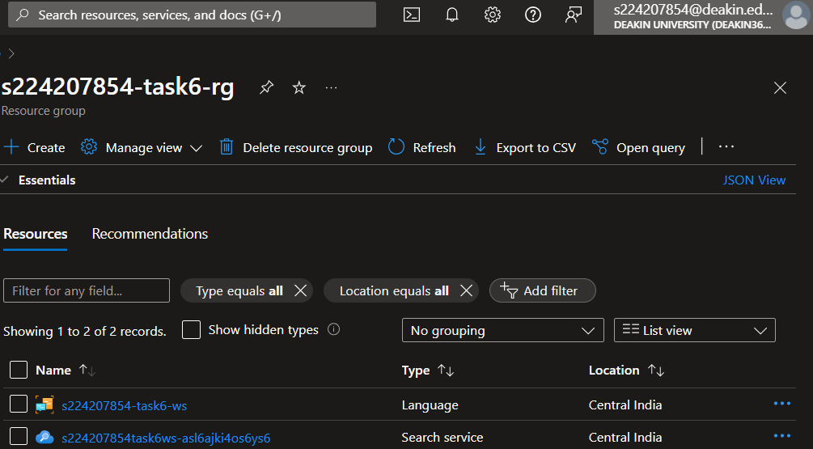

1. Creating language service in Azure AI services­­­­

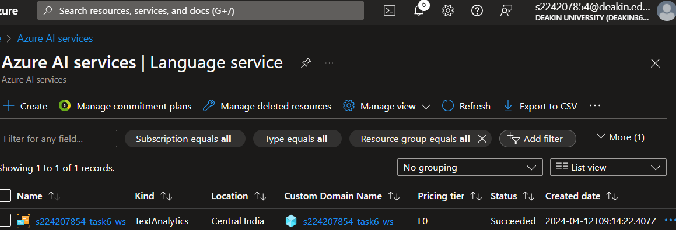

1. In Azure AI service we can visit our language service

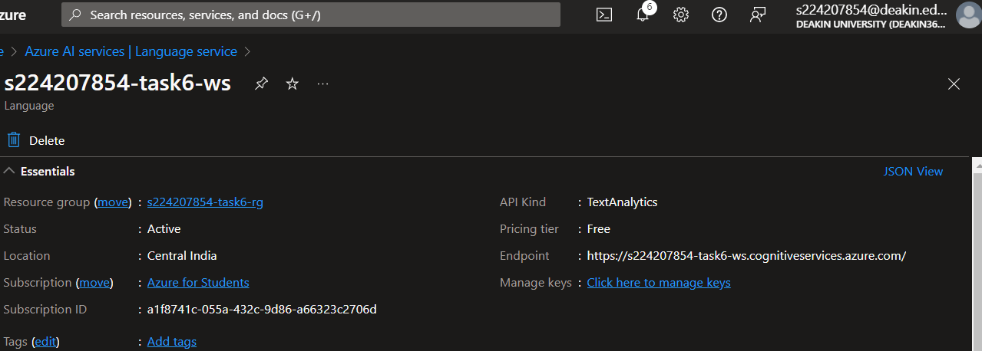

1. Installing Azure question-answering library



1. Importing different libraries and loading subscription key and endpoint from .env file for Azure client.

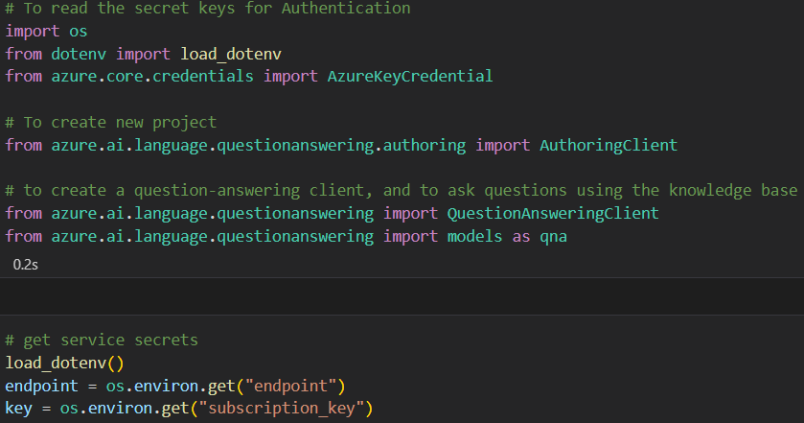

1. Once pre-requisites are done, we can use these info for our case study i.e. ICICI bank loan system FAQ for personal loan, home loan and car loan.

## **Azure Language Service Notebook**

In our notebook we will be using azure authoring client to create new project, add knowledge base and then deployment. In the below code snippet, 3 steps have been followed, i.e.:

* Create new project in Language Studio and can be checked here: <https://language.cognitive.azure.com>
* Add knowledge base to your project. A minimum of one knowledge base is required.
* Once our knowledge base is ready, we can deploy our project for the usage as BOT or attach it to a different channel like Facebook, Telegram.

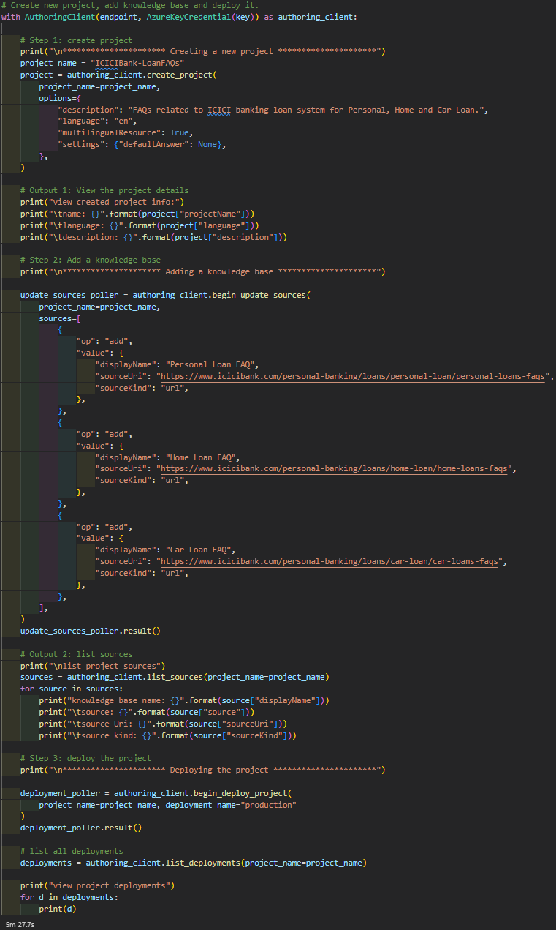

* Output of above snippet

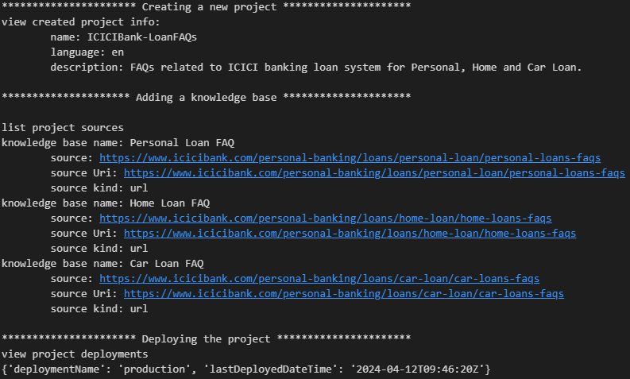

* We can check our project from language studio

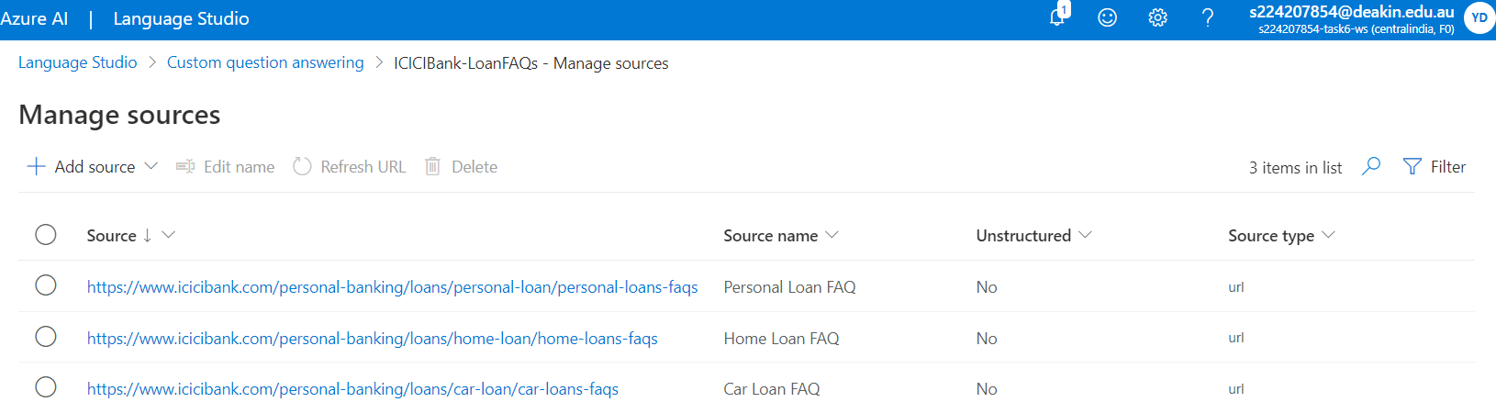

* Deployment of knowledge base can also be done from UI and after that we can use it as BOT for our service.

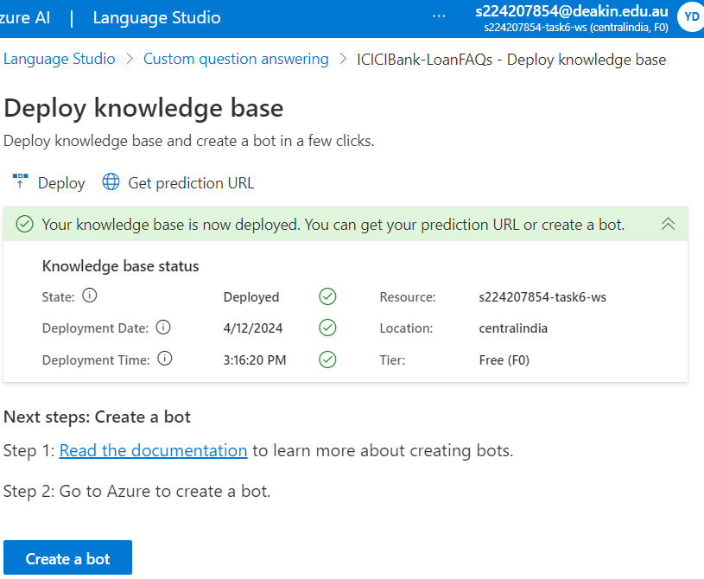

## **Testing**

For testing our Azure language service, we will be using question-answer client.

In the below code snippet, we are using deployed project and with confidence threshold more than 50%, we are taking that answer as our output to the service.

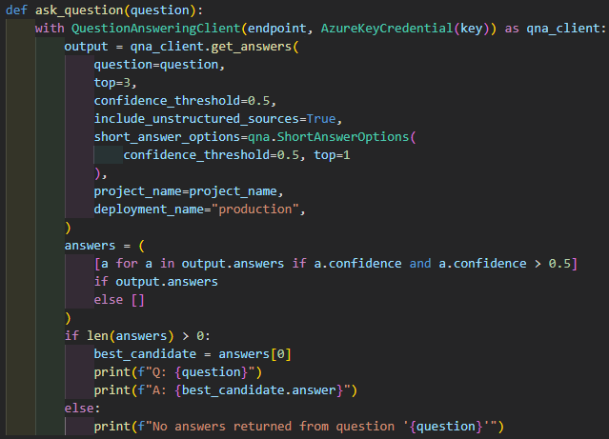

### Question Test-1

* Input question: *personal loan interest rate?*



### Question Test-2

* Input question: *offer me tea in bank?*



## **Bot Creation and plugging to channel**

In this case study we are using GroupMe application for BOT testing.

### Create a GroupMe application

1. Go to the GroupMe developers’ site and sign in to your account.
2. [Create a GroupMe application](https://dev.groupme.com/applications/new) for your bot.
   1. Enter a name for your application.
   2. For the Callback URL, enter <https://groupme.botframework.com/Home/Login>.
   3. Enter the rest of the information requested.
   4. Agree to GroupMe's terms of use and branding standards.
   5. Select **Save** to complete creation of the app.
3. Get your app credentials

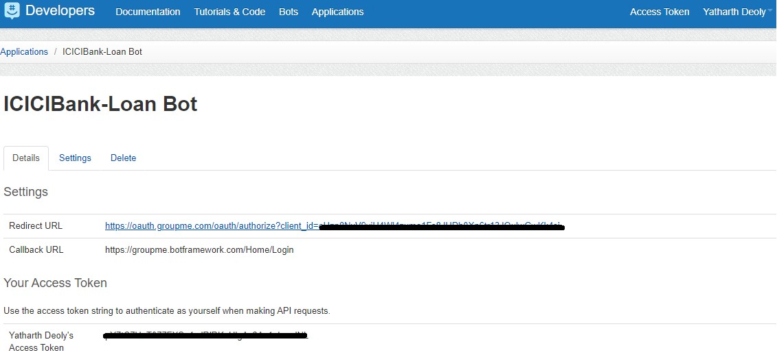

### Configure bot in Azure

1. Create bot from ‘Create a bot’ button present in Deploy knowledge base page.
2. In custom deployment full-up the details as per required. In Language Resource Key, please provide subscription key that has been used by our SDK.
3. Once deployment is completed, got-to the BOT.
   1. BOT which has been deployed can be tested via UI using ‘Test in Web Chat’ feature present in Azure bots.

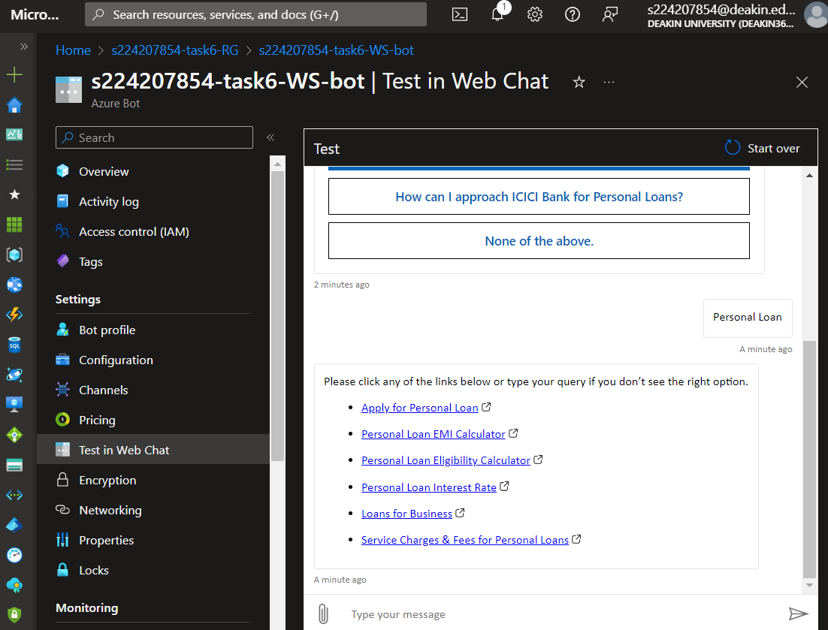

* 1. Open Channels and select GroupMe. Enter the required information.
  2. Once done, we can check the added channels in our portal

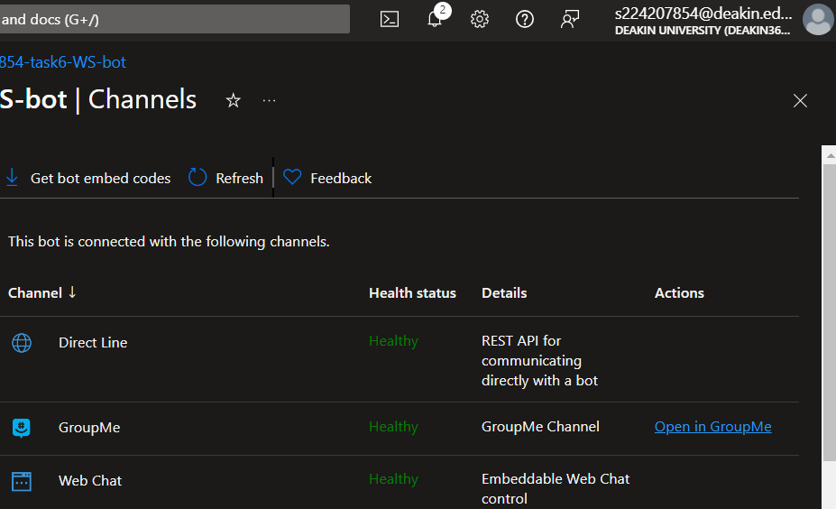

## **BOT Testing**

Once all configuration is done, please go-to your [GroupMe](https://web.groupme.com/chats) application, and select your created BOT.

### Test-1

Positive case scenario tested

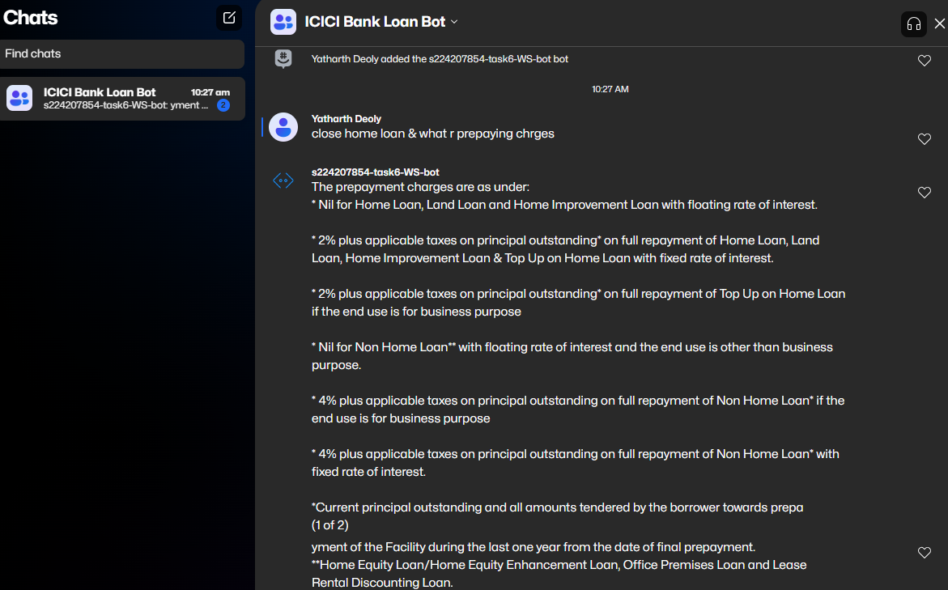

### Test-2

Positive case scenario tested

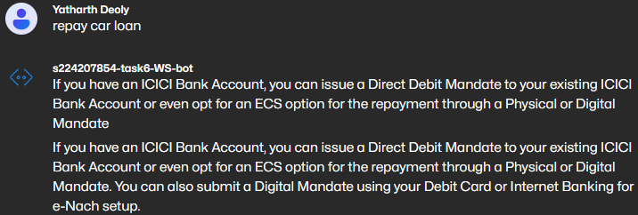

### Test-3

Negative case scenario tested

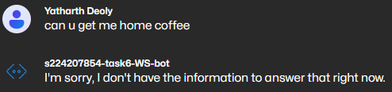

## **Resource Creation Clean-up**

Once task has been completed, will start resource clean-up activity. We can directly clean the resource from our “Resource groups” section, which will remove all resources created under this group, like bot, language service, storage, workspace and more.

## **Summary**

In this task we have learnt about natural language processing using BOT service and the usage of Azure with language service. Using pre-defined libraries to predict answers for different questions.

# **Bibliography**

Learning, Great, 2024. *SIG788 - Engineering AI solutions Content.* [Online]   
Available at: https://olympus.mygreatlearning.com/courses/109578?module_id=747613  
[Accessed 18 April 2024].

Microsoft, 2022. *Configure a bot to run on one or more channels.* [Online]   
Available at: https://learn.microsoft.com/en-us/azure/bot-service/bot-service-manage-channels?view=azure-bot-service-4.0  
[Accessed 18 April 2024].

Microsoft, 2024. *Connect a bot to GroupMe.* [Online]   
Available at: https://learn.microsoft.com/en-us/azure/bot-service/bot-service-channel-connect-groupme?view=azure-bot-service-4.0  
[Accessed 18 April 2024].